RESUME

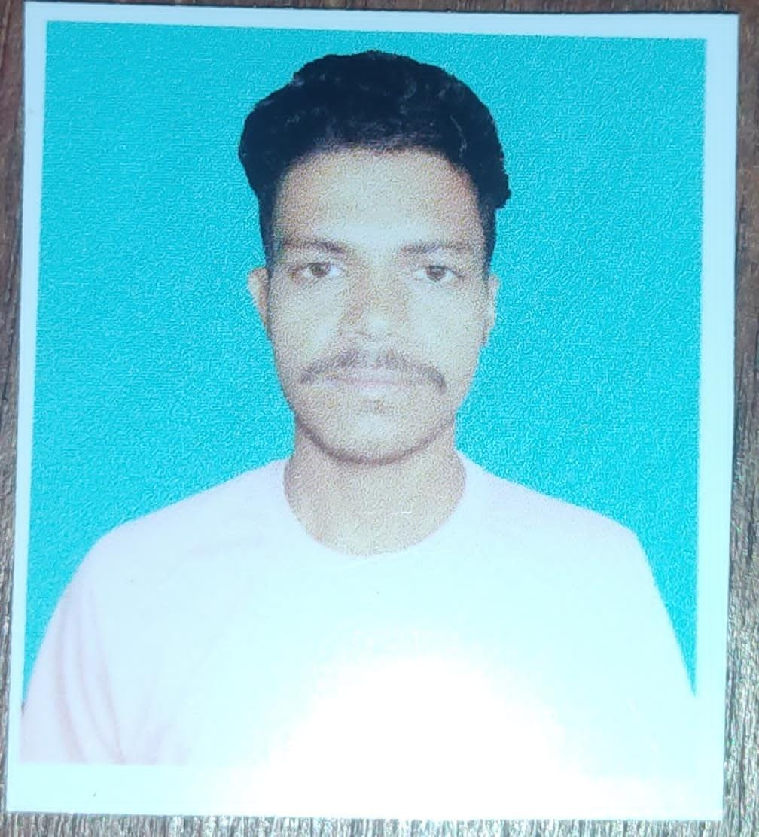

HIMANSHU KUMAR

D/O- Amarendra kumarAddress; - bank akorhi gola (Rohtas)

Pin- 821301

Mob: - +91-6200344596

Email Id: rajh8734@gmail.com

**Objective**

Seeking a career that is challenging and interesting, and lets me work on the leading areas

of technology, a job that gives me opportunities to learn, innovate and enhance my skills and strengths in conjunction with company goals and objectives.

**Academic Profile**

|  |  |  |  |  |  |
| --- | --- | --- | --- | --- | --- |
| **Sl. No** | **Course** | **School/college** | **Board/University** | **Year of passing** | **Percentage**  **/CGPA** |
| 1 | 10th  (Matriculation) | Daroga parsad ray h/s Chanda rohtas | BSEB | 2019 | 66% |
| 2 | Diploma (CivilEngineering) | GEMS Polytechnic college | SBTE | 2022 | 75% |

**Technical Skills**

* MS Office**: -** MS Word, MS Excel, MS PowerPoint
* AutoCAD (2010) & Rivet
* Internetability

**Projects and Seminars**

**Minor project**: Tinny house

**Seminar:** Seminar on-site inspection

**Training**

* One week winter training in GEMS Construction Department(Bihar)

**Extra-Curricular Activities**

* Member of Indian Society for Technical Education(2021-2024)
* Taken Part in various curricular activities in school and college (as act play and deliveringspeech).

**Strengths**

* Power of meditation and being spiritual nature(doingYoga)
* Inherent nature of communication skill, house-keeping and takingseminar
* Good managerial and planningSkill.
* Having good mental strength full devotion at given or plannedwork
* Accepting my weakness and trying toimprove
* Curious to learn newthings
* Ability to cope with failures and try to learn fromthem

**Achievement**

* Got the first prize in throwballmatch
* Got the first prize in relay race

**Personal Details**

Father’sName : Amarendra kumar

Gender : male

DateofBirth : 23/04/2004

Nationality : Indian

Hobbies : listening music

Interest : SocialWork

Languages Speak &Write : English,Hindi

MaritalStatus : Single

**Declaration**

I hereby declare that all the information mentioned above is true and complete to the

best of my knowledge and belief.

Date:26/08/2022 Place: Akorhi gola

Himanshu Kumar